# Team 4

|  |
| --- |
| Name: Xavier Tay Cher Yew  Admin No: P2129512 |
| Name: Nabil Ridhwanshah Bin Rosli  Admin No: P2007421 |

# Task List

|  |  |  |
| --- | --- | --- |
| **S/N** | **Page File** | **Done By** |
| 1 | Add_category.jsp | Nabil |
| 2 | All_tours.jsp | Nabil, Xavier |
| 3 | Edit_category.jsp | Nabil |
| 4 | Edit_tour.jsp | Xavier |
| 5 | Edit_tourDates.jsp | Xavier |
| 6 | Edit_tourCategories.jsp | Xavier |
| 7 | Edit_tourImages.jsp | Xavier |
| 8 | Navbar_dark.jsp | Nabil, Xavier |
| 9 | Navbar.jsp | Nabil, Xavier |
| 10 | Categories.jsp | Xavier |
| 11 | categoryListing.jsp | Xavier |
| 12 | Detail.jsp | Nabil, Xavier |
| 13 | View_all.jsp | Nabil, Xavier |
| 14 | Login.jsp | Nabil |
| 15 | Profile.jsp | Nabil, Xavier |
| 16 | Signup.jsp | Nabil |
| 17 | Wishlist.jsp | Nabil |
| 18 | Index.jsp | Nabil, Xavier |

|  |  |  |
| --- | --- | --- |
| **S/N** | **Servlet File** | **Done By** |
| 1 | LeaveAReview.java | Nabil |
| 2 | Login.java | Nabil |
| 3 | LogOut.java | Nabil |
| 4 | ModifyUser.java | Nabil |
| 5 | RegisterForTour.java | Xavier |
| 6 | RemoveWishlist.java | Nabil |
| 7 | SignUp.java | Nabil |
| 8 | AddNewCategory.java | Nabil |
| 9 | DeleteCategory.java | Nabil |
| 10 | EditCategory.java | Nabil |
| 11 | EditTour.java | Xavier |
| 12 | EditTourDate.java | Xavier |
| 13 | EditTourImage.java | Xavier |
| 14 | TourPageRemoveWishlist.java | Xavier |
| 15 | TourPageAddWishlist.java | Xavier |

|  |  |  |
| --- | --- | --- |
| **S/N** | **Filename** | **Done By** |
| 1 | _DatabaseConnectionConfig.java/ DatabaseConnectionConfig.java | Xavier |
| 2 | DatabaseConnection.java | Xavier |
| 3 | IDatabaseQuery.java | Xavier |
| 4 | IDatabaseUpdate.java | Xavier |
| 5 | Password.java | Nabil |
| 6 | Util.java | Nabil, Xavier |
| 7 | CategoryModel.java | Nabil, Xavier |
| 8 | TourModel.java | Nabil, Xavier |
| 9 | UserModel.java | Nabil, Xavier |
| 10 | WishlistModel.java | Nabil, Xavier |
| 11 | Category.java | Xavier |
| 12 | Tour.java | Xavier |
| 13 | User.java | Xavier |
| 14 | Wishlist.java | Nabil |

# Wireframes

## Landing Page

## Log In

## Sign Up

## Categories Page

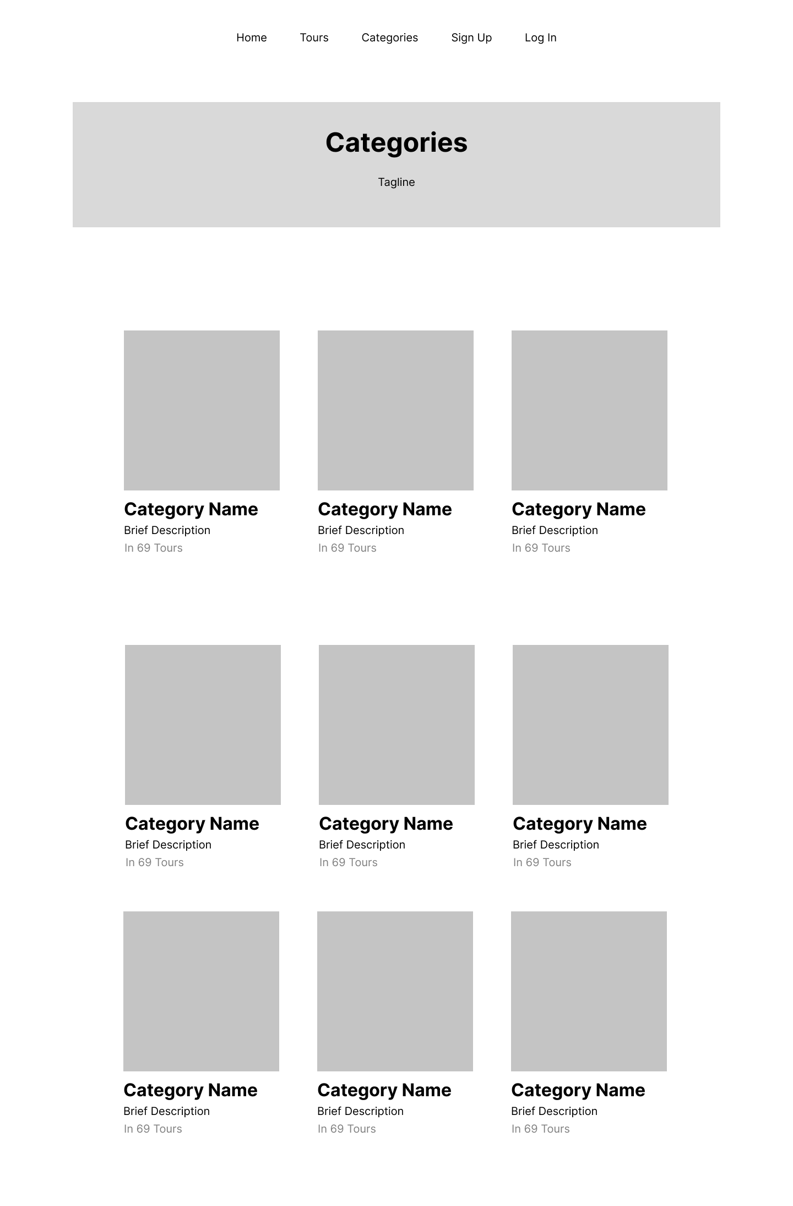

## Category Landing Page

## All Tour/Search page

## Wishlist

## Tour Detail

## Admin

### View All Tours

### Add Category

### Edit Category

### Edit Tour

### Edit tour date / Add tour date

### Edit tour image / Add tour image

# ER Diagram

## Old (Given before holidays)

## New (Submission)

Changes are:

* tour_registration
  + add “pax” column - smallint
* wishlist
  + tour_date_id to tour_id

## Notable features

* Image upload (add category page)
* Password hashing (using SHA-512) (No salt or pepper though)
* One tour can have multiple dates and images
* Wishlist feature
* Not much but in terms of project management, we used Trello

